Evolutionary Creationism: Scientific and Biblical Perspectives*
David S. Barnes Ph.D.
Professor of Biology, Emeritus,
Roberts Wesleyan College, Rochester, NY
ABSTRACT
Evolutionary Creationism (EC) is a key bridge in bringing together, at least in dialogue, young earth creationists (YEC), those embracing intelligent design, and humanists. EC is defined in this paper as affirming that God is the creator and sustainer of the universe, and that God has used evolutionary processes to create some and perhaps virtually all the vast diversity of present and extinct life. EC accepts that evolutionary processes provide the best current scientific model for the diversity of life and do not compromise Biblical inerrancy.
The paper presents an overview of the Biblical and scientific basis of YEC and EC. It considers the significance of the ancient understanding of the cosmos in the Bible, which was accepted in one or more forms from Babylonian and Egyptian antiquity to the Genesis account, and then addresses Galileo’s innovations in the seventeenth century. The author presents aspects of YEC including human evolution critiqued from the Biblical perspectives of C.S. Lewis, John Stott, Billy Graham, and Pope John Paul II.
The paper also considers the influence of culture wars on science/faith issues including those addressed by EC; Gallop and Pew Research Center poll data on the perceptions on origins of scientists and the general public; and the significance of theological concepts beyond the limits of scientific critique.
A. Introduction
The focus of this paper is Evolutionary Creationism, which addresses the issue of origins. The paper will include an overview of three common understandings of origins within Christianity i.e., Young Earth Creationism (YEC), Evolutionary Creationism (EC) and Intelligent Design (ID); Ancient near eastern world pictures; and Origins in 21st Century America: Thoughts about moving forward.

The author assumes God is revealed through two “books” i.e. the Bible and nature; The former studied by theologians and the latter by scientists. God is the author of both. Thus, there can be no final conflict between these but misinterpretations of the data. (The basic concept goes back to 2nd century Justin Martyr.)
Does Evolutionary Creationism (EC) have realistic potential in being a bridge in the science/faith issue of origins? The following polling data of American adults and scientists will help provide a context.
A 2017 Gallup Poll (1) reported 38% of American adults believed that “God created humans in present form;” 38% believed “Human beings developed over millions of years, but God guided the process,” and 19% believe “Human beings developed over millions of years, but God had no part in the process.”
A February 2019 Pew Research Center Poll (2) found that 18% of American adults believed that humans have existed since the beginning of time;” 48% believed that “humans have evolved over time due to processes that were guided or allowed by God or a higher power;” 33% believed that “Humans have evolved over time due to processes such as natural selection; God or a higher power had no role in this process.”

* Presented at the following conferences: “Scripture, Theology and the Sciences, October 25-26, 2019, Northeastern Seminary, Rochester, NY and “Science Through the Eyes of Faith”, Greenville University, Greenville IL November 8-10, 2019.

A 2015 Pew Research Center Poll (3) indicated that 90% of scientists who are members of the 120,000 member American Association for the Advancement of Science AAAS believed that “humans and other living beings evolved without the guidance of a supreme being; 8% by evolution “guided by a supreme being;” and 2% “Have existed in their present form since the beginning of time.”
As reported in Nature, about 40% of prominent U.S. scientists believed in a personal God in 1916; the same percent in 1996 (polled those listed in the 1995 American and Women of Science) some 80 years later (4).
In a 2013 study by the Royal Society 92% of the members reported that they did not believe in a personal God. Larson and Witman 1998 found that 92% of the members of the U.S. National Academy of Sciences did not believe in God or a higher power.

B. Common Understandings of Origins

Young Earth Creationism: The major tenets of Young Earth Creationism (YEC) are (a) The Bible must be interpreted in its literal form. If not, we threaten its integrity as the word of God. (b) God created the universe including the world in six 24-hour days, and all species (living & extinct) 6,000-10,000 years ago.

YEC perceives the earth appears to be very old but this is largely the result of Noah’s flood (flood geology); a world- wide flood that took place about 2348 BC. (5) All species now living survived Noah’s flood. YEC accepts microevolution (evolution within species) and rejects macroevolution (evolution from one species to another species) and common descent. There was no death before Adams’s sin.

YEC is most extensively promoted by Answers in Genesis, www.answersingenesis.org. founded by Ken Ham. The organization presents evidence to support YEC biblical and science views (commonly known as Creation Science) and critiques evidence supporting evolutionary creationism and atheistic evolution.

Evolutionary Creationism: Evolutionary Creationism (EC) is defined in this paper as (a) affirming that God is the creator, and sustainer of the universe. (b) It appears from a careful study of nature (science) and the Bible (theology) that God used evolutionary processes to create some and perhaps virtually all the vast diversity of present and extinct life. God is the God of physical (naturalistic) processes and miracles.

EC interprets the ancient understanding of the cosmos in the Bible including Genesis within its ancient historical scientific & literary context. It was written for us but not to us. EC perceives the best scientific estimate of the earths age is 4.6 billion years, and that of the universe 13.7 billion years, that the fossil and genome records clearly support concepts of common ancestry, and macroevolution and animal death before the sin of Adam. It accepts of intelligent design but in a more nuanced less “God of the gaps” manner than YEC. EC rejects the philosophy of evolutionism. EC offers the integration of a view of biblical inerrancy and evolutionary processes. Some, within EC e.g., Old Testament Scholar, Professor John Walton of Wheaton College, suggest that Adam was a historical person but his primary function in Scripture is to represent all of humanity (6,7).
EC is most extensively presented by BioLogos www.biologos.org founded by Francis Collins, a physician and geneticist who led the Human Genome Project and is currently the Director of the National Institutes of Health; The American Scientific Affiliation www.asa3.org,, Christians in Science www.cis.org.uk., and The Faraday Institute for Science and Religion www.faraday-institute.org.

Intelligent Design: Intelligent Design (ID) is the theory that life, or the universe, cannot have arisen by chance and was designed and created by some intelligent entity. ID accepts the age of the earth as 4.6 billion years and the universe as 13.7 billion years. However, it rejects macroevolution and common descent. Evidence for ID comes from the profoundly fine-tuned nature of the universe and the amazing complexity of cellular, mechanisms the e.g. blood clotting and flagella as in bacteria and sperm. These seem consistent to with the need of an intelligent designer.

At the same time, the problems of pain and apparent evil in the world are mysteries as are seemingly bad designs e.g. appendix and pseudogenes* and hard to explain designs from a ID perspective, e.g., embryonic teeth in modern whales that regress before birth and non-functional leg bones in adult whales that are very similar to functional leg bones in mammals. Further, there is no way to “prove” a particular God was involved i.e. Jehovah as in Judaism, Jesus and Jehovah as in Christianity; Allah as in Islam; and other deities in other cultures. At the same time many of the apparent gaps in scientific understanding, which were attributed to an intelligent designer, have been more recently filled.

ID is most extensively promoted by the Discovery Institute www.discovery.org. Key members have included William Dembski, Michael Behe and Stephen Meyer.

There is of course no way to scientifically prove which of the above is correct. This is simply not within the bounds of science. There are positions that may seem unreasonable to many scientists that are justifiable for Christians to hold because of additional assumptions they bring to the discussion.

For example: EC can provide strong data as to age of the earth from studies of tree rings, carbon dating, sediment layers in lake beds, ice rings in glaciers of Antarctica and Greenland, salts deposits in the Dead Sea, coral growth, fossil cores in oil fields, continental drift, transitional fossils, and light from distant stars. EC’s support for common descent and macroevolution is based on diverse disciplines such as comparative anatomy, physiology, embryology, genetics, biochemistry, paleontology and more recently from genomic research.

However, YEC can counter that God created the earth in six 24-hour days with the appearance of old age - millions or billions of years if necessary. It simply appears old. For a critique, consider chapter 5 of Haarsma’s “Origins” (6). They also consider potential gaps in nature that they feel only God can fill – issues such as various views of mutation rates, and more recently, connective tissue in dinosaur bones.

Table 1. Common positions on origins with the inclusion of the AAAS data.

Positions on Origins | Theology | Age of earth/universe | Creation/Evolution
Young Earth Creationism | Biblical inerrancy | 6,000-10,000 years | Rejects Evolution other than Microevolution
Evolutionary Creationism | Biblical inerrancy within the literary & scientific context of Bible | Earth 4.6 Billion  Universe 13.7 Billion | God Guided Evolution  Rejects Evolutionism
Intelligent Design | Does not name Intelligent entity | No position | Designed and created by Intelligent Entity
American Association for the Advancement of Science - members | Various views of the Bible | Earth 4.6 Billion  Universe 13.7 Billion | 8% God used evolutionary processes  87% God not involved

Common western views of origins can be put on a continuum from Evolutionism, Deism, Evolutionary Creationism to Young Earth Creationism. Given the nature of science, none of these can prove through science the origin of the universe, earth or life. But what of those who feel that the ancient understanding of the cosmos in the Bible, in particular the Genesis creation account, was inspired by God to reflect aspects of the ancient near eastern world picture, widely accepted by Jews and Christians until the 17th century, rather than a 21st century scientific picture? John Walton, Professor of Old Testament at Wheaton College observes,

“Through the entire Bible, there is not a single instance in which God revealed to Israel a science beyond their own culture. No passage offers a scientific perspective that was not common to the Old-World science of antiquity.” (7)

First, we need to differentiate world picture from world view.

*pseudogene - a gene which undergone a mutation and no longer functions e.g. Most mammals have a gene coding for making Vitamin C. Humans and chimps have the gene in a mutated form i.e. a pseudogene, which does not produce Vitamin C. The presence of pseudogenes is consistent with an EC view.

C. World views and world pictures

A world view is a set of basic assumptions we have about the world. Aristotle in the 4th century B. C. understood that events had a teleological explanation, that of purpose. Thus, acorns grow to become oak trees; a moving cart stops because rest is its natural state. There was no need for and little interest in a modern scientific explanation. Thomas Aquinas, 13th century theologian, perceived God to be a combination of Aristotle’s abstract creator (unmoved mover) and the Bible’s personal father; earth, the center of the universe created by God; and humans, the highest creation.

Aquinas would answer the following questions as follows. To answer the question of “Who are we?” God’s creatures. “Where are we from?” The Garden of Eden. “Where are we going?” Moving through history to final judgement. “What time is it?” Near the end. A Christian world view is expressed more completely in the Apostles Creed – in slightly different forms since the 4th century to the present.

A world picture is developed through observation over time through the senses and is greatly influenced by scientific advancement. The ancient science in the Bible, and especially that in Genesis Chapters 1 and 2 was influenced by one or more forms from Babylonian and Egyptian antiquity. Aspects of these were incorporated into the Genesis account and largely remained in Christendom to the 17th century of Galileo. What was this ancient science?
The Ancient Near Eastern World Pictures

The ancient science in the near Eastern world pictured a three-tiered universe i.e. Think of a round plate (earth) covered by an upside-down cereal bowl (the firmament) with the underworld below the plate and God’s home (heaven) above the bowl (8,9).
The near Eastern world picture influenced Biblical authors who pictured ideas such as the earth is flat and circular, bordered by a sea; the earth is immovable; a solid domed structure (the firmament) holds up a body of water over the earth and the sun moves across the sky (9). This model in varying forms was commonly accepted within Judaism and Christianity until the 16th and 17th centuries. Was the model over the centuries simply a metaphor e.g. “Shepherd” as in “The Lord is my Shepherd” or as describing the actual physical structure of the earth i.e., not a metaphor? Figure 2 presents an ancient understanding of the cosmos in the Bible: a 3-Tier Universe.

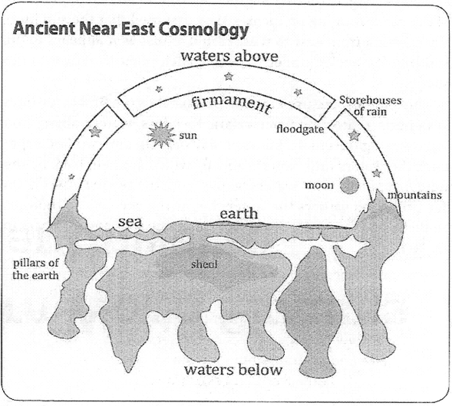
Figure 1. Ancient Near East Cosmology (8) Figure 2. The Ancient Understanding of the Cosmos in the Bible: The 3-Tier Universe (9).

Figure 3. presents an Egyptian understanding of the cosmos.

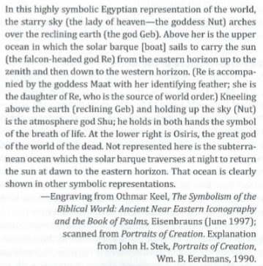
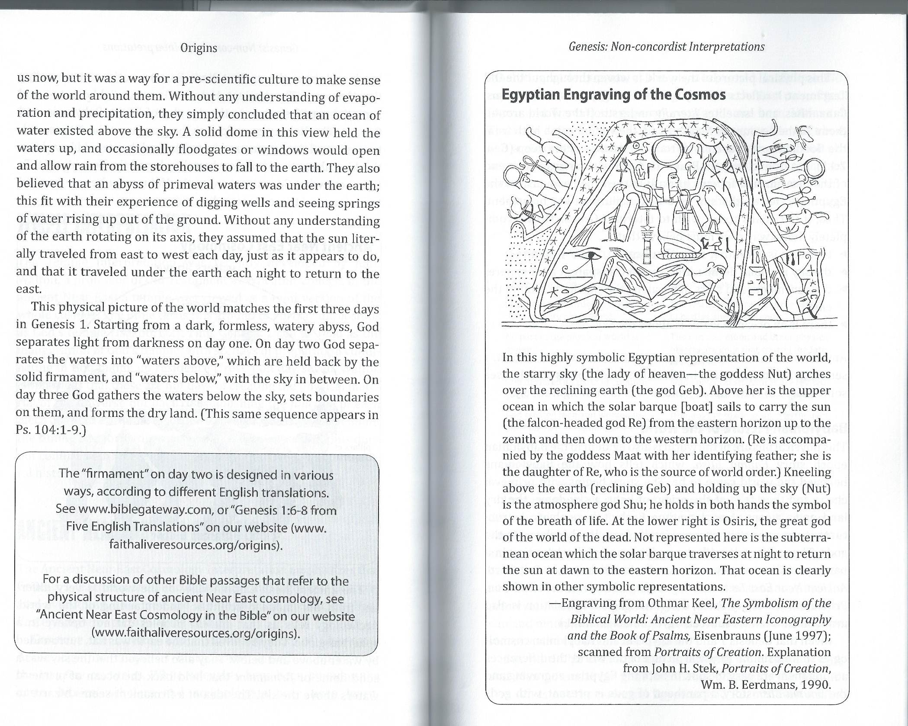
Figure 3. Egyptian Engraving of the Cosmos (8)

D. Origins in 21st Century America: Thoughts about moving forward.
Culture Wars
We are currently living in the context of a ‘culture war” in which understandings of the past conflict with the present and projected future. These can have profound implications for understanding faith/science perceptions. Recall the issues of 1960’s - civil rights, the Vietnam war, the environment, promiscuity and civil disturbances that lead to mistrust among university students to authority and sparked the backlash expressed in the “moral majority” and the religious right.
Earlier issues at the turn of the century such as the theory of evolution, the Scopes trial, immigration of Catholics from Ireland and eastern Europe, biblical higher-criticism, communism, the failure of prohibition, and the “roaring twenties”, collectively helped replace the optimism of the late 19th century e.g. Manifest Destiny, and spark conservative Protestant cultural isolation and Fundamentalism. Even earlier, the religious, political and scientific climate e.g. Galileo’s heliocentric writings, fueled the 17th century Roman Catholic Inquisition.
Our ‘current war’ is fanned by extremism that include positions on interrelated factors from post-modernism, political polarization, poverty and income distribution, to globalization, immigration, climate warming, technology and the economy. While Christians are sensitive to these, they are often more uniquely sensitive to issues such as vulgarity, crudeness, sex, and violence in the media; divorce, abortion, easy acceptance of premarital sex, gender identification, trans-gender and gay issues.
Conservative Christians feel their faith and the country is in retreat from biblical teaching and tradition. For many, this is not the time to rethink their admittedly very conservative stand on biblical inerrancy and creation science but rather a time to “circle the wagons” and protect their own families and cultures. For many of them, the rethinking of origins just adds another battlefront to the stress.
Christians and non-Christians are now challenged to reconcile issues of science and faith including human evolution. Many college and university students, faculty and administrators on some secular and Christian college and seminary campuses, may feel that it is not prudent to address these science/faith issues due to several factors. These include the potential loss of student personal faith, potential division within their organization, employment issues, and loss of financial support. The same may be true of churches and clergy and those within large interdenominational Christian organizations who depend on the loyalty of a broad group of supporters.
The perception in the secular world is that “scientific creationism” is commonly dismissed as defensive, shallow, at times lacking intellectual honesty, outside of mainline science, subject to little peer review, the defense of a “false history” of the earth (8), loosely associated with the political right and a vocal and a unnecessary appendage to Christian faith. It appears wedded to a rigid, narrow, and unnecessary definition of “Biblical inerrancy.” It is commonly thought to be a major stumbling block to interest, among university students, in Christian faith. Is this a well-founded perception?
This is not denying the legitimate historical interest many Christians have in Creation Science and the difficulty they have in accepting the concept of a God-authored evolutionary creation. However, for others Christian faith combines the best of Christian tradition, biblical inerrancy and modern evolutionary thought within a Christian context.
In the Christian world, Catholics have the benefit of an authoritative hierarchical structure; a Pope, and well-funded “think-tanks” composed of scientists and theologians to provide the Vatican, the scientific world, and the general public insight and direction on science/faith issues.
On the other hand, Protestant churches and denominations often have lacked the benefit of a strong hierarchical structure. While they have a core set of beliefs, they are more diverse in other theological perspectives, cultural histories and traditions. This is reflected in issues relating to origins. Protestant theologians and scientists have lacked a large, cohesive, well-funded stage to present, discuss, and rethink science/faith issues. The development of the internet and the growth of para-church organizations is changing this.
Human Evolution – Theological Perspectives
Many Christians in and out of the sciences find the data from The Human Genome Project, and the determination of the genomes of other species of great interest. They are beginning to better understand factors in disease cause, diagnosis, and treatment. They are interested in the theological implications for human origins and evolution. Issues range from genetic determinism, the historicity of Adam and Eve, and original sin to gene editing and what it means to be human. They want to hear from the theologians, especially those who are commented both biblical inerrancy and scientific inquiry.
In considering human evolution, consider the thoughts of the following 20th, 21st century highly respected Christian leaders namely, C.S. Lewis, John R.W. Stott, and Billy Graham, and Pope John Paul II and a word of caution from 5th century, Saint Augustine.
C.S. Lewis: C.S. Lewis is considered one of the most profound Christian authors and scholars of the 20th century. Here is an interesting quote.

“That man is physically descended from animals I have no objection…For long centuries God perfected the animal form which was to become the vehicle of humanity and the image of Himself…
The creature may have existed for ages in this state before it became man… In the fullness of time, God caused to descend upon this organism, both on its psychology and physiology, a new kind of consciousness which could say 'I' and 'me,' which could look upon itself as an object, which knew God, which could make judgments of truth, beauty, and goodness… (10).

Rev. Dr. John R.W. Stott: Britain's Leading Evangelical Theologian and author of 50 books

“But there does not seem any biblical reason for denying that some kind of purposive evolutionary development may have been the mode which God employed in creating.” “But my acceptance of Adam and Eve as historical is not incompatible with my belief that several forms of pre-Adamic “hominid” seem to have existed for thousands of years previously. It is conceivable that God created Adam out of one of them; ““Adam was the first homo divinus” (11).

Rev. Billy Graham: Billy Graham is recognized as being the greatest Christian evangelist of the 20th
century. The following are his views on creation science and human origins.

"I don't think that there's any conflict at all between science today and the Scriptures.
I think that we have misinterpreted the Scriptures many times and we've tried to make the Scriptures
Say things they weren't meant to say. I think that we have made a mistake by thinking the Bible is a
scientific book.”

“The Bible is not a book of science. The Bible is a book of Redemption, and of course I accept the
Creation story. I believe that God did create the universe. I believe that God created man, and whether it came by an evolutionary process and at a certain point He took this person or being and made him a living soul or not, does not change the fact that God did create man. ... whichever way God did it makes no difference as to what man is and man's relationship to God" (12).

Pope John Paul II: Head of the Catholic Church 1978 to 2005

“New findings lead us toward the recognition of evolution as more than a hypothesis.”
“If the origin of the human body comes through living matter which existed previously, the spiritual soul is created directly by God” (13).

What Are These Theologians Saying?
What are the above theologians saying to our general American culture composed religiously of Catholics; Fundamentalists, Evangelicals, and Mainline Protestants; Jews, Muslims, and others? What are they saying to university, faculty, and students, to academics, scientists to the general population?

They are saying that it is consistent with their understanding of the Bible that God may have formed humans using evolutionary processes from a lower pre-human. They are not saying that God did create humans from pre-human(s), but they perceive that both science and scripture together confirm that this may have been how God created humans. They are affirming Evolutionary Creationism.

They are giving a sense of permission to all including Young Earth Creationists to examine both young earth creationism and evolutionary creationism from the view of modern science and a view of biblical inerrancy in a climate of openness and transparency. They are assuring Christian and non-Christian scientists in academia and industry that evolutionary creationism is founded on the concept that God has given us two books one of a God of grace and redemption and the other nature, his creation. Now for St. Augustine’s 5th century caution.

St. Augustine A.D. 354-430 Caution

In writing about avoiding setting up unnecessary stumbling blocks to the gospel. Saint Augustine, who lived many centuries before the modern debates about origins, evidently faced a similar problem in his day. He wrote,

“Usually, even a non-Christian knows something about the earth, the heavens, and the other elements of this world, about the motion and orbit of the stars and even their size and relative positions, about the predictable eclipses of the sun and moon, the cycles of the years and the seasons, about the kinds of animals, shrubs, stones, and so forth, and this knowledge he holds to as being certain from reason and experience.

Now, it is a disgraceful and dangerous thing for an infidel to hear a Christian, presumably giving the meaning of Holy Scripture, talking non-sense on these topics; and we should take all means to prevent such an embarrassing situation, in which people show up vast ignorance in a Christian and laugh it to scorn. The shame is not so much that an ignorant individual is derided, but that people outside the household of the faith think our sacred writers held such opinions, and, to the great loss of those for whose salvation we toil, the writers of our Scripture are criticized and rejected as unlearned men” (14).

E. Conclusion:

So, where do Christians find truth in the questions of origins? Again, the historical answer is that God is revealed through “two books,” i.e. God’s book, the Bible, the book of creation and redemption; and God’s creation – Nature. Both books provide data. The Bible is the primary source of redemption, the story of who and why; the scientific method is the primary source of gaining and evaluating data regarding nature.

There will always be those who accept Naturalistic Evolutionism, others, Evolutionary Creation and still others, Young Earth Creationism. No amount of evidence will satisfy. There is the potential for endless debate. All sides can cite brilliant scientists and theologians.

As paleontologist, evolutionary biologist, Stephen Jay Gould commented “Either half of my colleagues are enormously stupid, or else the science of Darwinism is fully compatible with conventional religious beliefs – and equally compatible with atheism, thus providing that the two great realms of nature’s factually and the source of human morality do not strongly overlap” (15).

Christians may well agree with Gould that “the science of Darwinism is compatible … with atheism” but insist that Evolutionary Creationism is also compatible both with God’s design and use of evolutionary mechanisms and the inerrancy of scripture. They perceive the “two great realms of nature’s factually and the source of human morality” do strongly overlap. The primary problem is not in the data but the interpretation of the data.

Finally, Christians and non-Christians should consider that the major theological concepts that are the heart of the gospel, are essentially outside the bounds of scientific critique. These include among others the existence of God who created and sustains the earth, the resurrection of Christ, the trinity, prayer, miracles, and eternal life. The “who” and why of creation is God.
All religions include MYSTERY. For Evolutionary Creationists these mysteries include among others, aspects of animal and human pain, evil, the sovereignty of God and free-will, predestination and the openness of God; the created cannot fully understand the creator.
On the other hand, the author perceives that the “how” of creation is best served by the proposition that the science of the Bible was inspired to be within the context of the contemporary scientific thought in which it was written i.e., ancient science. This essentially removes the obligation to use the science of the Bible to prove the existence of God and disprove evolution.
Bibliography
- Gallup, “In U.S. Belief in Creationist View of Humans at New Low.” May 22, 2017.
- Pew Research Center, “The Evolution of Pew Research Center’s Survey Questions About the Origins and Development of Life on Earth”. February, 6, 2019.
- Pew Research Center, “An Elaboration of AAAS Scientists’ Views.” July 23, 2015.
- Larson, E.J and L. Witham “Scientists are Still Keeping the Faith” Nature 386 (1997): 435-436.
- David Wright “Timeline for the Flood.” March 9, 2012.
- Emmert, Kevin “The Lost World of Adam and Eve.” March 19, 2015.
- Walton, John “The Lost World of Genesis: One Ancient Cosmology and the Origins Debate” Downers Grove, IL: InterVarsity Press (2009)
- Deborah B. Haarsma & Loren D. Haarsma, “Origins: Christian Perspectives on Creation, Evolution, and Intelligent Design”, Grand Rapids MI: Faith Alive Ministries (2011) Chapter 6.
- Dennis O. Lamoureux “I Love Jesus & I Accept Evolution” Eugene, OR: Wipf and Stock Publishers, (2009) Chapter 3.
- C.S. Lewis “The Problem of Pain” Grand Rapids, MI: Zondervan (2001) p. 67.
- Stott, John R. W. “Understanding the Bible” Grand Rapids, MI: Zondervan Publishing House, (1984) p. 55.
- Frost, David, “Billy Graham: Personal Thoughts of a Public Man,” Colorado Springs: Charlot Victor Publishers, (1997) p.72-74.
- Pope John Paul II “Message to the Pontifical Academy of Sciences: On Evolution,” (1996).
- Augustine A.D. 354-430 The Literal Meaning of Genesis.
- Gould, Stephen Jay. “Impeaching a Self-Appointed Judge.” Scientific American 267, no. 1 (1992): 118–121.

