Mammals
Bat
Beaver
Black Bear
Bobcat
Coyote
Deer Mouse
Eastern Chipmunk
Eastern Cotton-tailed Rabbit
Flying Squirrel
Gray Squirrel
Gray Fox
House Mouse
Little Brown Bat
Meadow Jumping Mouse
Mink
Muskrat
Porcupine
Raccoon
Red Fox
River Otter
Red Squirrel
Shrew
Striped Skunk
Virginia Opossum
Vole
Weasel
White-footed Mouse
White-tailed Deer
Woodchuck

Amphibians
American Toad
Bull Frog
Green Frog
Northern Leopard Frog
Pickerel Frog
Red-spotted Newt
Spring Peeper

Reptiles
Common Garter Snake
Eastern Painted Turtle
Snapping Turtle

Fish
Brown Bullhead
Chain Pickerel
Largemouth Bass
Northern Pike
Redbreast Sunfish

Birds
Song Birds
American Crow
Barn Swallow
Black-capped Chickadee
Blue Jay
Chipping Sparrow
Dark-eyed Junco
Downey Woodpecker
European Starling
Hairy Woodpecker
Hermit Thrush
House Sparrow
Northern Cardinal
Red-winged Blackbird
Robin
Tree Swallow
Tufted Titmouse
White-breasted Nuthatch
Wood Thrush
Yellow-bellied Sapsucker

Birds of Prey
Bald Eagle
Eastern Screech Owl
Great Blue Heron
Great Horned Owl
Osprey
Sharp-shinned Hawk
Turkey Vulture

Water Birds
American Black Duck
Canada Goose
Common Merganser
Mallard
Lesser Scaup
Wood Duck

Game Birds
Ringed-necked Pheasant
Ruffed Grouse
Wild Turkey

Trees, Bushes & Flowers

Deciduous Trees | Genus & Specie*
Allegheny  Serviceberry | Amelanchier laevis  am-el AN-keer LAY  viss
American  Basswood | Tilia americana  TIL-ee-ah ah-mer-ih  KAH-nah
American  Beech | Fagus grandifolia  FAY - gus gran-dih FLOOR-ah
American  Elm | Ulmus americana  UL-mus ah-mer-ih KAY-nah
American  Hornbeam | Carpinus caroliniana  Kir-PY-nus
Apple | Malus pumila  MAY-lus
Birch,  Black | Betula lenta  BET-choo-lah
Gray | Betula populifolia  Pop-yew-lh-FOE-lee-ah
Yellow | Betula alleghanienis
Black Cherry | Prunus serotina  PREW-nus
Chokecherry | Prunus virginiana  PREW-nus ver-gin- ee-AY-nah
Eastern  Hophornbeam | Ostrya virginiana  OSS-tree-ah ver-gin- ee- AY-nah
Flowering  Dogwood | Conus cordiformis
Hickory,  Bitternut | Carya cordiformis  KAR-ee-ah
Pignut | Carya glabra  KAR-ee-ah
Maple,  Red | Acer rubrum  AY-sir RU-brum
Striped | Acer pensylvanicum  AY-sir pen-sil-VAN-ih- cum
Sugar | Acer saccharum  AY-sir SAK-har-um
Northern Red  Oak | Quercus rubra  KWER-kus Roo-brab
Quaking  Aspen | Populus tremuloides  POP-yew-lus
Scarlet  Hawthorn | Crataegus pedicellata  Krah-TEE-gus
Staghorn  Sumac | Rhus typhina  RUS ty-FEE-nah
White Ash | Fraxinus americana  FRAKS-in-us-ah-mer-ih-KAY-nah

Evergreen Trees
Eastern Hemlock | Tsuga canadensis  SU-gah kan-ah-DEN-sis
Pine,  Eastern White  Red  Scotch | Pinus strobus  PY-nus STROE-bus  Pinus resinosa  PY-nus rez-ih-NO-  sah  Pinus sylvestris  PY-nus sil-VES-tris
Spruce,  Norway  Red | Picea abies  py-SEE-ah AB-ee-ays  Picea rubens  py-SEE-ah

* Latin names - Phonetic spelling also provided in most cases.To hear the Latin genus & species pronounced go to www.finegardening.com
Bushes | Genus & Specie
Autumn Olive | Elaeagnus umbellata  el-ee-AG-nus  um-bell-AY-tah
Barberry | Berberis vulgaris  BER-ber-iss
Blackberry | Rubus fruticosus  RU-bus
Elderberry | Sambucus nigra  Sam-BU-kus NY-grah
Honeysuckle | Lonicera  lon-ISS-er-ah
Huckleberry | Vaccinium corymbosum  Vak-SIN-ee-um  kor-is-BO-sum
Mountain-laurel | Jakmia latifolia  La-ti-FO-lee-a
Multi-flora Rose | Rosa multiflora  RO-sah
Pokeweed | Phytolacca
Raspberry | Rubus idaeus  RU-bus
Rhododendron | Rhododendron maximum  Roe-doe-DEN-dron
Winterberry | Ilex verticillata  EYE-leks ver-tih-sih-LAY-tah

Flowers
Aster | Indian Pipe
Black-eyed Susan | Iris
Burdock | Jack-in-the-Pulpit
Cattail | Pickerelweed
Clover | Queen Anne's Lace
Daisy | Strawberry
Day Lily | Touch-me-not
Goldenrod

Ferns, Fungi, etc
Hey scented fern Bracken fungus
Bracken fern Mushroom
Interrupted fern Puffball fungus
Lycopodium (ground pine) Ink Caps fungus

Please send suggestions to Dr. David Barnes
abarnes2@rochester.rr.com
Animals
and
Plants
at
Camp Timberledge

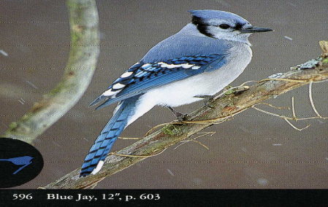

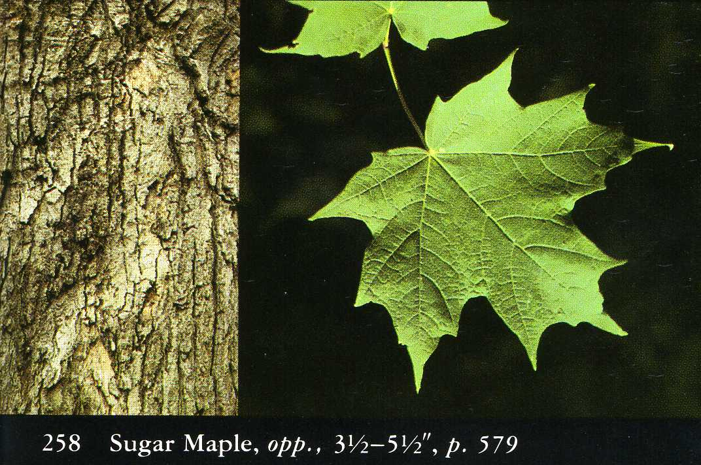

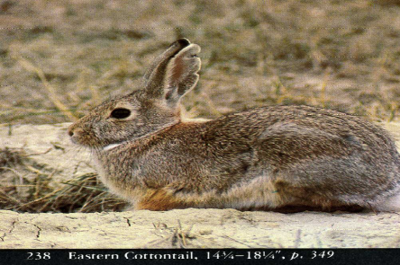

Camp Timberledge
Beach Lake, PA 18405
570-729-7230
www.camptimberledge.org
January 2014

